Key writing texts at a glance - Cycle 1
Year 1 and 2 | Aut 1 | Aut 2 | Spr 1 | Spr 2 | Sum 1 | Sum 2
Year 1 and 2 | 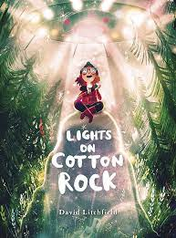  Lights on Cotton Rock | 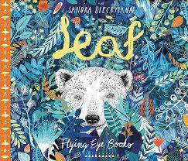  Leaf | 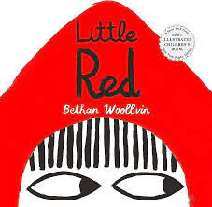  Little Red | 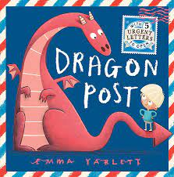  Dragon Post | 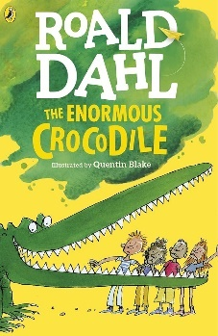  The Enormous Crocodile | 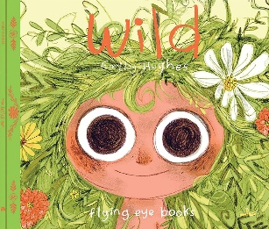  Wild
Year 3 and 4 | Aut 1 | Aut 2 | Spr 1 | Spr 2 | Sum 1 | Sum 2
Year 3 and 4 | 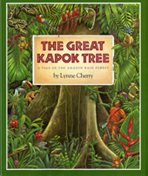  The Great Kapok Tree | 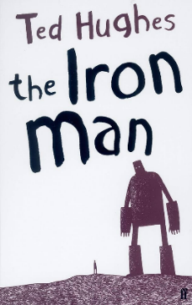  The Iron Man | 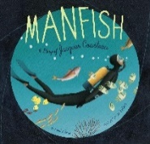  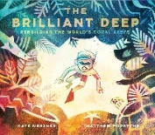  Manfish &  The Brilliant Deep | 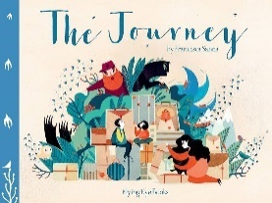 The Journey | 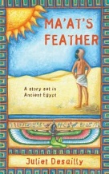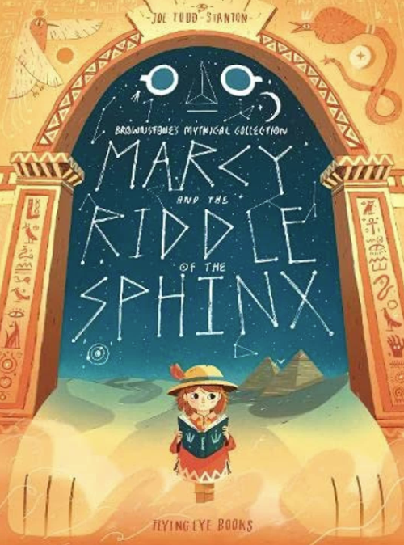  Ma’at’s feather  Marcy and the riddle of the sphinx | 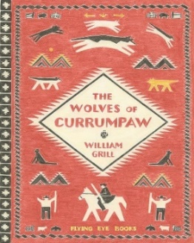  The wolves of Currumpaw
Year 5 and 6 | Aut 1 | Aut 2 | Spr 1 | Spr 2 | Sum 1 | Sum 2
Year 5 and 6 | 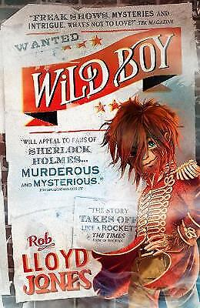  Wild Boy | 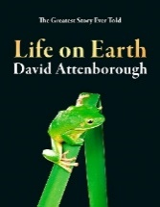  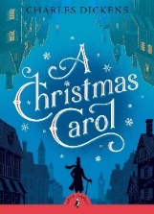  Life on Earth  A Christmas Carol | 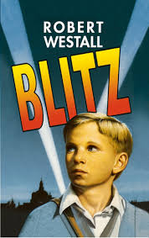  Blitz | 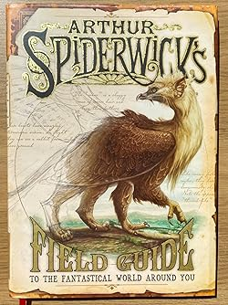  Spiderwick’s Field Guide | 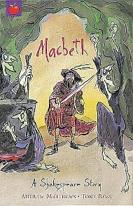  Macbeth | 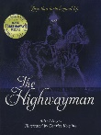  Yr5- The Highway man
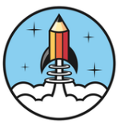
Yr6- Writing project
Key writing texts at a glance - Cycle 2
Year 1 and 2 | Aut 1 | Aut 2 | Spr 1 | Spr 2 | Sum 1 | Sum 2
Year 1 and 2 | 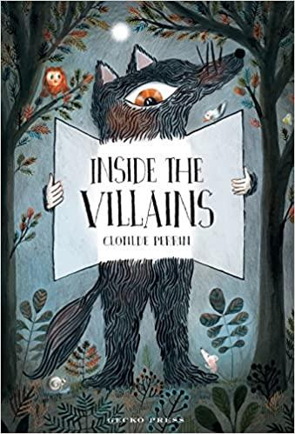  Inside the Villains | 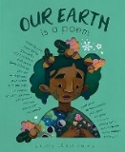  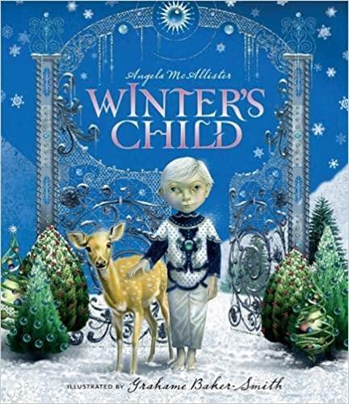  A Winter’s child  Our Earth is a Poem | 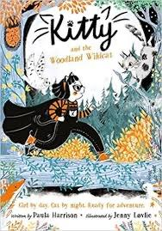  Kitty and the Woodland Wildcat | 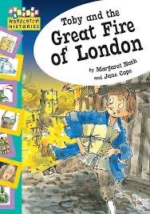  Toby and the Great fire of London | 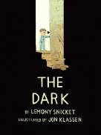  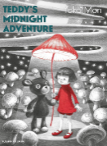  The dark  Teddy’s midnight adventure | 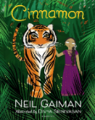  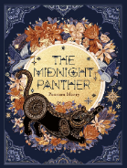  The midnight panther  Cinnamon
Year 3 and 4 | Aut 1 | Aut 2 | Spr 1 | Spr 2 | Sum 1 | Sum 2
Year 3 and 4 | 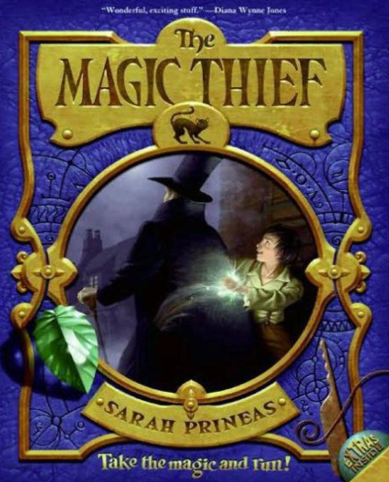  The Magic Thief | 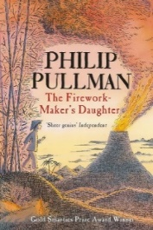  The Firework Maker’s Daughter | 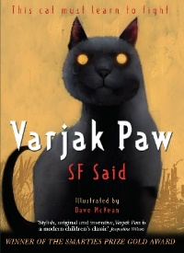  Varjak Paw | 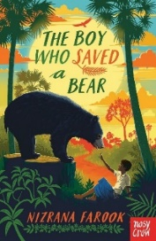  The boy who saved bear | 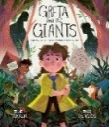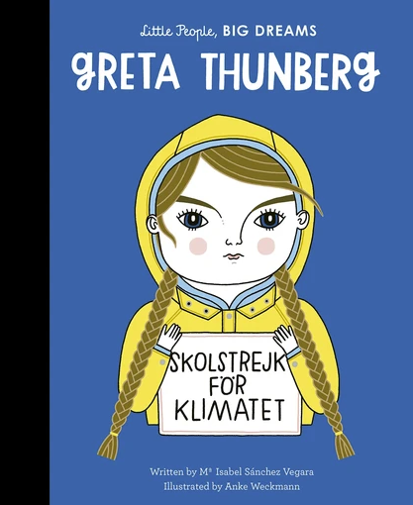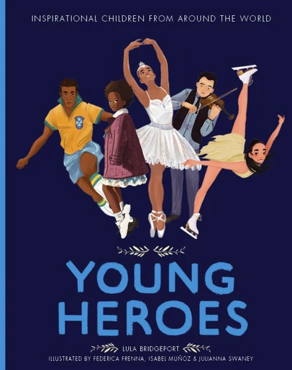  Greta Thunberg- Little People, Big Dreams’  ‘Young Heroes’  ‘Greta and the Giants’ | 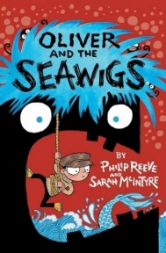  Oliver and the Seawigs
Year 5 and 6 | Aut 1 | Aut 2 | Spr 1 | Spr 2 | Sum 1 | Sum 2
Year 5 and 6 | 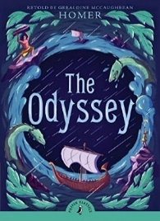  The Odyssey | 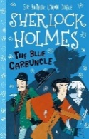  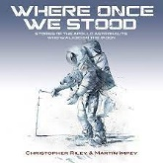  Where once we stood  The Blue Carbuncle | 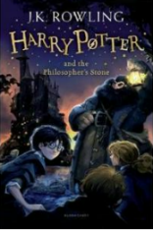  The Philosopher’s Stone | 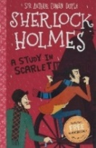  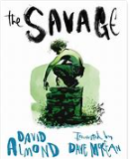  The Savage  A Study in Scarlet | 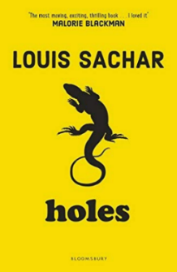  Holes | Yr5- The Highway man
 |  |  |  |  |  | Yr6- Writing project

