Highfield CE Primary School
Supporting Pupils with Medical Needs Policy



Approved by: | The Governing Body | Date: 13 May2026
Last reviewed on: | May 2026
Next review due by: | May 2027

“Gracious words are like a honeycomb, sweetness to the soul and health to the body.”
Proverbs 16:24

Aims
This policy aims to ensure that:

- Pupils, staff and parents understand how our school will support pupils with medical needs
- Pupils with medical needs are properly supported to allow them to access the same education as other pupils, including school trips and sporting activities

The governing body will implement this policy by:

- Making sure sufficient staff are suitably trained
- Making staff aware of pupils’ medical needs, where appropriate
- Making sure there are cover arrangements to ensure someone is always available to support pupils with medical needs
- Providing supply teachers with appropriate information about the policy and relevant pupils
- Developing and monitoring individual healthcare plans (IHPs) if required for individual children

The named person(s) with responsibility for implementing this policy is the school SENCo Rachael Bond.

Legislation and statutory responsibilities
This policy meets the requirements under Section 100 of the Children and Families Act 2014, which places a duty on governing bodies to make arrangements for supporting pupils at their school with medical needs.

It is also based on the Department for Education’s statutory guidance on supporting pupils with medical needs at school.

Roles and responsibilities
The Governing Body

The governing body has ultimate responsibility to make arrangements to support pupils with medical needs and fulfilling its statutory duties under legislation. The governing body will ensure that sufficient staff have received suitable training and are competent before they are responsible for supporting children with medical needs.

The headteacher/SENCo
The headteacher/SENCo will:
- Make sure all staff are aware of this policy and understand their role in its implementation
- Ensure that there is a sufficient number of trained staff available to implement this policy and deliver against all individual healthcare plans (IHPs), including in contingency and emergency situations
- Ensure that all staff who need to know are aware of a child’s medical need
- Take overall responsibility for the development of IHPs
- Make sure that school staff are appropriately insured and aware that they are insured to support pupils in this way
- Contact the school nursing service in the case of any pupil who has a medical need that may require support at school, but who has not yet been brought to the attention of the school nursing service
- Ensure that systems are in place for obtaining information about a child’s medical needs and that this information is kept up to date

Staff
- Supporting pupils with medical needs during school hours is not the sole responsibility of one person. Any member of staff may be asked to provide support to pupils with medical conditions, although they will not be required to do so. This includes the administration of medicines.
- Those staff who take on the responsibility to support pupils with medical needs will receive sufficient and suitable training, and will achieve the necessary level of competency before doing so.
- Teachers will take into account the needs of pupils with medical conditions that they teach.
- All staff will know what to do and respond accordingly when they become aware that a pupil with a medical need requires help.

Parents
- Provide the school with sufficient and up-to-date information about their child’s medical needs
- Be involved in the development and review of their child’s IHP and may be involved in its drafting if this is required
- Carry out any action they have agreed to as part of the implementation of the IHP, e.g. provide medicines and equipment, and ensure they or another nominated adult are contactable at all times

Pupils
- Pupils with medical needs will often be best placed to provide information about how their condition affects them.
- Pupils should be fully involved in discussions about their medical support needs and contribute as much as possible to the development of their IHPs, where applicable.
- They are also expected to comply with their IHPs.

School nursing service and other healthcare professionals
- Our school nursing service will notify the school when a pupil has been identified as having a medical need that will require support in school. This will be before the pupil starts school, wherever possible. They may also support staff to implement a child’s IHP.
- Healthcare professionals, such as GPs and paediatricians, will liaise with the school’s nursing service and notify them of any pupils identified as having a medical condition. They may also provide advice on developing IHPs.

Equal Opportunities
Our school is clear about the need to actively support pupils with medical needs to participate in school trips and visits, or in sporting activities, and not prevent them from doing so.

The school will consider what reasonable adjustments need to be made to enable these pupils to participate fully and safely on school trips, visits and sporting activities.

Risk assessments will be carried out so that planning arrangements take account of any steps needed to ensure that pupils with medical needs are included. In doing so, pupils, their parents and any relevant healthcare professionals will be consulted.

Identifying a child that has a medical need at induction
We have a system in place that ensures any medical conditions are identified before the child starts at the school. Please see Appendix A, which is the procedure followed by the admin team when receiving induction paperwork from the parents to ensure know medical condition is missed.

Being notified that a child has a medical need
If a pupil is already on role, the parent must notify the school that their child now has a medical need, the process outlined below will be followed to decide whether the pupil requires an IHP. Please see Appendix B.

The school will make every effort to ensure that arrangements are put into place within 2 weeks, or by the beginning of the relevant term for pupils who are new to our school.

Individual Healthcare Plans (IHPs)
The headteacher has overall responsibility for the development of IHPs for pupils with medical needs. This has been delegated to the school’s Deputy Headteacher, Rachael Bond with the support of Jeanette White, fully qualified Paediatric first aid trained member of our support staff (Rachael and Jeannette are referred to as the school’s Medical Team). Plans will be reviewed at least annually (in July), or earlier if there is evidence that the pupil’s needs have changed.

Plans will be developed with the pupil’s best interests in mind and will set out:
- What needs to be done
- When
- By whom

Not all pupils with a medical condition will require an IHP. It will be agreed with a healthcare professional and the parents when an IHP would be inappropriate or disproportionate. This will be based on evidence. If there is no consensus, the headteacher will make the final decision.

Plans will be drawn up in partnership with the school, parents and a relevant healthcare professional, such as the school nursing service, specialist or paediatrician, who can best advise on the pupil’s specific needs. The pupil will be involved wherever appropriate.

IHPs will be linked to, or become part of, any education, health and care (EHC) plan. If a pupil has SEN but does not have an EHC plan, the SEN will be mentioned in the IHP.

The level of detail in the plan will depend on the complexity of the child’s condition and how much support is needed. We will use the 2014 government template Appendix 2 or (https://assets.publishing.service.gov.uk/government/uploads/system/uploads/attachment_data/file/349437/Supporting_pupils_with_medical_conditions_-_templates.docx) and the Southampton City Councils Guidance for school for all IHPs. Please see Appendix C for the schools general form.

The Medical Team, will consider the following when deciding what information to record on IHPs:
- The medical need, its triggers, signs, symptoms and treatments
- The pupil’s resulting needs, including medication (dose, side effects and storage) and other treatments, time, facilities, equipment, testing, access to food and drink where this is used to manage their need, dietary requirements and environmental issues, e.g. crowded corridors, travel time between lessons
- Specific support for the pupil’s educational, social and emotional needs. For example, how absences will be managed, requirements for extra time to complete exams, use of rest periods or additional support in catching up with lessons, counselling sessions
- The level of support needed, including in emergencies. If a pupil is self-managing their medication, this will be clearly stated with appropriate arrangements for monitoring
- Who will provide this support, their training needs, expectations of their role and confirmation of proficiency to provide support for the pupil’s medical need from a healthcare professional, and cover arrangements for when they are unavailable

- Who in the school needs to be aware of the pupil’s need and the support required Arrangements for written permission from parents and the headteacher for medication to be administered by a member of staff, or self-administered by the pupil during school hours
- Separate arrangements or procedures required for school trips or other school activities outside of the normal school timetable that will ensure the pupil can participate, e.g. risk assessments
- Where confidentiality issues are raised by the parent/pupil, the designated individuals to be entrusted with information about the pupil’s need
- What to do in an emergency, including who to contact, and contingency arrangements

Managing Medicines
Prescription and non-prescription medicines will only be administered at school:
- When it would be detrimental to the pupil’s health or school attendance not to do so and
- Where we have parents’ written consent and clear instructions

The only exception to this is where the medicine has been prescribed to the pupil without the knowledge of the parents. Pupils under 16 will not be given medicine containing aspirin or medication which contains ibuprofen unless prescribed by a doctor. Anyone giving a pupil any medication (for example, for pain relief) will first check maximum dosages and when the previous dosage was taken. Parents will always be informed before any pain-relief medication is given, to ensure there is no risk of an overdose occurring.

The school will only accept prescribed medicines that are:
- In-date
- Labelled
- Provided in the original container, as dispensed by the pharmacist, and include instructions for administration, dosage and storage
- Unopened container e.g. Calpol

The school will accept insulin that is inside an insulin pen or pump rather than its original container, but it must be in date.

All medicines will be stored safely in a lockable cabinet - the top drawer at the Juniors and the green cube cabinet in the medical cupboard at the Infants. If medication needs to be stored in a cold environment, it will be kept in a locked fridge in the medical room (Juniors) or the Chestnut room (Infants).

Pupils will be informed of the location of their medicines at all times. Essential medicines and medical devices, such as asthma inhalers, blood glucose testing meters and adrenaline pens, will always be readily accessible to pupils, not locked away, and stored in the pupil’s class medical bag at the infants and the central medicine storage cabinet in the staff room at the juniors, clearly labelled with the pupil’s photo and name.

When medicines are no longer required, they will be returned to parents for safe disposal.

Controlled Drugs
Some medicines prescribed for children (e.g. methylphenidate, known as Ritalin) are controlled by the Misuse of Drugs Act. Members of staff are authorised to administer a controlled drug, in accordance with the prescriber’s instructions. A child may legally have a prescribed controlled drug in their possession. The school/setting will keep controlled drugs in a locked non-portable container, to which only named staff will have access. A record of access to the container will be kept. Misuse of a controlled drug is an offence and will be dealt with under the school’s behaviour policy.

Pupils Managing their Own Needs
Pupils who are competent will be encouraged to take responsibility for managing their own medicines and procedures e.g. administering their own inhaler. This will be discussed with parents and it will be reflected in their IHPs.

Staff will not force a pupil to take a medicine or carry out a necessary procedure if they refuse, but will follow the procedure agreed in the IHP and inform parents so that an alternative option can be considered, if necessary.

Unacceptable Practice
School staff should use their discretion and judge each case individually with reference to the pupil’s IHP, but it is generally not acceptable to:
- Prevent pupils from easily accessing their inhalers and medication and administering their medication when and where necessary
- Assume that every pupil with the same need requires the same treatment
- Ignore the views of the pupil or their parents
- Ignore medical evidence or opinion (although this may be challenged)
- Send children with medical needs home frequently for reasons associated with their medical needs or prevent them from staying for normal school activities, including lunch, unless this is specified in their IHPs
- If the pupil becomes ill, send them to the school office or medical room unaccompanied or with someone unsuitable (i.e. not a first aider or another pupil.)
- Penalise pupils for their attendance record if their absences are related to their medical need, e.g. hospital appointments
- Prevent pupils from drinking, eating or taking toilet or other breaks whenever they need to in order to manage their medical need effectively
- Require parents, or otherwise make them feel obliged, to attend school to administer medication or provide medical support to their pupil, including with toileting issues. No parent should have to give up working because the school is failing to support their child’s medical needs
- Prevent pupils from participating, or create unnecessary barriers to pupils participating in any aspect of school life, including school trips, e.g. by requiring parents to accompany their child
- Administer, or ask pupils to administer, medicine in school toilets

Emergency Procedures
- As part of general risk management processes the school will have arrangements in place for dealing with emergency situations (Appendix E).
- Staff will follow the school’s normal emergency procedures (for example, calling 999). All pupils’ IHPs will clearly set out what constitutes an emergency and will explain what to do.
- In the event of a medical emergency, school staff will follow the emergency procedures, including calling 999 if necessary (Guidance for calling 999 is in Appendix D).
- Other children should know what to do in the event of an emergency, such as telling a member of staff.
- If a pupil needs to be taken to hospital, staff will stay with the pupil until the parent arrives, or accompany the pupil to hospital by ambulance.
- A member of staff will always accompany a child taken to hospital by ambulance and will stay until the parent arrives.
- Health professionals are responsible for any decisions on medical treatment when parents/carers are not available.

- Staff should never take children to hospital in their own car; it is safer to call an ambulance.
- Individual Pupil Health Care Plans will include instructions as to how to manage a child in an emergency and identify who has the responsibility in an emergency. Those with responsibility at different times of day (e.g. lunchtime supervisor) will need to be very clear of their role.

Training
Staff who are responsible for supporting pupils with medical needs will receive suitable and sufficient training to do so. The training will be identified during the development or review of IHPs. Staff who provide support to pupils with medical needs will be included in meetings where this is discussed.
The relevant healthcare professionals will lead on identifying the type and level of training required and will agree this with the SENCo. Training will be kept up to date.

Training will:
- Be sufficient to ensure that staff are competent and have confidence in their ability to support the pupils
- Fulfil the requirements in the IHPs
- Help staff to have an understanding of the specific medical need they are being asked to deal with, their implications and preventative measures
- Healthcare professionals will provide confirmation of the proficiency of staff in a medical procedure, or in providing medication.
- All staff will receive training so that they are aware of this policy and understand their role in implementing it, for example, with preventative and emergency measures so they can recognise and act quickly when a problem occurs. This will be provided for new staff during their induction.

Record Keeping
- The governing body will ensure that written records are kept of all medicine administered to pupils for as long as these pupils are at the school.
- Parents will be informed if their pupil has been unwell at school.
- IHPs are kept in a readily accessible place which all staff are aware of and are stored in the medical bag in each classroom and a copy is the school office.
- They are saved on the school network but only accessible by the Headteacher, Medical Team and SENCO.

Day Trips, Residential Visits and Sporting Activities and Residentials
Pupils with medical conditions will be supported to participate in school trips, sporting activities and residential visits.

Prior to an activity taking place, the school will conduct a risk assessment to identify what reasonable adjustments should be taken to enable pupils with medical conditions to participate. In addition to a risk assessment, advice will be sought from pupils, parents and relevant medical professionals. The school will arrange for adjustments to be made for all pupils to participate, except where evidence from a clinician, e.g. a GP, indicates that this is not possible.

Defibrillator
- The school has a Mediana HeartOn A15 automated external defibrillator (AED). The AED will be stored in the headteachers office at the junior site on Hawthorn Road.
- All staff members and pupils will be made aware of the AED’s location and what to do in an emergency. A risk assessment regarding the storage and use of AEDs at the school will be carried out and reviewed annually.
- No training will be needed to use the AED, as voice and/or visual prompts guide the rescuer through the entire process from when the device is first switched on or opened; however, staff members will be trained in cardiopulmonary resuscitation (CPR), as this is an essential part of first-aid and AED use.
- The emergency services will always be called where an AED is used or requires using.
- Where possible, AEDs will be used in paediatric mode or with paediatric pads for pupils under the age of eight.
- Maintenance checks will be undertaken on AEDs on a weekly basis by the Medical Team, who will also keep an up-to-date record of all checks and maintenance work.

Risk Assessment and Management Procedures
- This policy will operate within the context of the school Health and Safety Policy.
- The school will ensure that risks to the health of others are properly controlled.
- The school will provide, where necessary, individual risk assessments for pupils or groups with medical needs.
- The school will be aware of the health and safety issues relating to dangerous substances and infection.

Liability and Indemnity
The governing body will ensure that the appropriate level of insurance is in place and appropriately reflects the school’s level of risk.

Complaints
Parents with a complaint about their child’s medical need should discuss these directly with the Headteacher or Medical lead (Deputy Headteacher) in the first instance. If the Headteacher or Deputy Headteacher cannot resolve the matter, they will direct parents to the school’s complaints procedure.

Monitoring Arrangements
This policy will be reviewed and approved by the governing body annually.

Links to Other Policies
This policy links to the following policies:
- Accessibility
- Administrating Medication
- Complaints
- Equality information and objectives
- First aid
- Health and safety
- Safeguarding
- Special educational needs information report and policy

Appendix A

Medical Needs Identified at Induction

Parents must complete all the induction forms before the child begin at the school
The Admin team enter all of the information into SIMS.
Any medical information is passed to the Medical Team
Medical Team will evaluate the information and decide if this will require an IHP to complete.
A draft of our IHP form (Appendix) to be sent to the parents for completion
Once returned to the Medical Team they will produce the IHP and share with the parent, school staff and the child, where appropriate.
A copy of the IHP will be put in the child’s classes medical bag in the IHP folder and duplicates will be put in the year groups folders and in the folder in the school office.

Appendix B

Process for Developing Individual Healthcare Plans (IHPs)
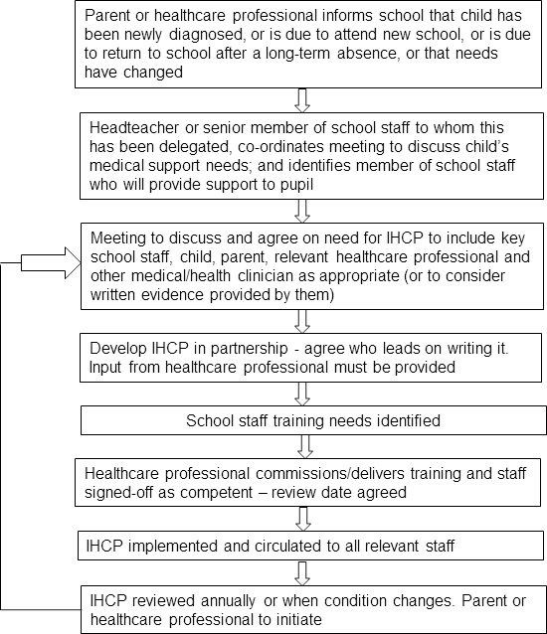
IHP

IHP

IHP

IHP


Appendix C
 | Individual Healthcare Plan
Name of school/setting |  | Highfield CE Primary School
Child’s name
Class
Date of birth
Child’s address
Medical diagnosis/condition
Date
Review Date |  | Annually
Family Contact information
Name
Relationship to child
Phone (work)
Phone (home)
Phone (mobile)
Name
Relationship to child
Phone (work)
Phone (home)
Phone (mobile)
Clinic/hospital contact
Name
Phone
G.P.
Name
Phone

Describe medical needs and give details of child’s symptoms, triggers, signs, treatments, facilities, equipment or devices, environmental issues, etc

Daily care requirements/Environment issues (e.g. before sport/at lunchtime)

Name of medication, dose, method of administration, when to be taken, side effects, contra-indications, administered by/self-administered with/without supervision

Additional arrangements for school visits/trips, etc.

Describe what constitutes an emergency and the action to take if this occurs.

Who is responsible in an emergency (state if different for off-site activities) (what do we do, who do we contact, contingency arrangements)

Plan developed with
Parents
Medical Team
Child

Staff training needed/undertaken – who, what, when

Form copied to (who needs to know – add in as needed):
Parents
Medical Lead
Office Medical Folder
Class Teacher - IHP folders

Appendix D

Contacting Emergency Services – Ambulance

Dial 999 (use a cordless and stay with the patient, as they are likely to ask questions about the patient) ask for an ambulance and be ready with following Info: -

- Your telephone number
School – 023 8055 5793

- Location
School –Hawthorn Road (Juniors)
School - Church Lane (Infants)

- Postcode
Juniors - SO17 1PX
Infants - SO17 1SY

- Location of the patient within the school

- Your name

- Child’s name

- Brief description of patient symptoms

- Suggest best entrance and state that the crew will be met and taken to location of the patient.
Speak clearly and be prepared to answer any other questions about the patient.

Appendix E

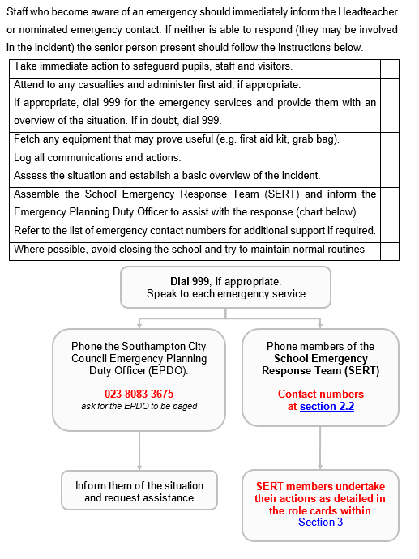
Emergency Procedures

