Highfield CE Primary School

Allegations against Staff (including Low-Level Concerns) Policy

Approved by: | The Date: 3.3.26  governing body
Last reviewed on: | 3.3.26
Next review due by: | March 2027

Southampton City Council’s Designated Officer is: Jemma Swann
Phone: 023 8091 5535
E-mail: LADO@southampton.gov.uk

Section 1: Allegations that May Meet the Harm Threshold
This section is based on ‘Section 1: Allegations that may meet the harm threshold’ in part 4 of Keeping Children Safe in Education.
This section applies to all cases in which it is alleged that a current member of staff, including a supply teacher, volunteer or contractor, has:
- Behaved in a way that has harmed a child, or may have harmed a child, and/or
- Possibly committed a criminal offence against or related to a child, and/or
- Behaved towards a child or children in a way that indicates they may pose a risk of harm to children, and/or
- Behaved or may have behaved in a way that indicates they may not be suitable to work with children – this includes behaviour taking place both inside and outside of school If we’re in any doubt as to whether a concern meets the harm threshold, we will consult out local authority designated officer (LADO).
We will deal with any allegation of abuse quickly, in a fair and consistent way that provides effective child protection while also supporting the individual who is the subject of the allegation.
A ‘case manager’ will lead any investigation. This will be the headteacher (Rosie Walford), or the chair of governors (Alan Hunt) where the headteacher is the subject of the allegation. The case manager will be identified at the earliest opportunity.
Our procedures for dealing with allegations will be applied with common sense and judgement.
If we receive an allegation of an incident happening while an individual or organisation was using the school premises to run activities for children, we will follow our safeguarding policies and procedures and inform our LADO.

Suspension of the accused until the case is resolved
Suspension of the accused will not be the default position, and will only be considered in cases where there is reason to suspect that a child or other children is/are at risk of harm, or the case is so serious that there might be grounds for dismissal. In such cases, we will only suspend an individual if we have considered all other options available and there is no reasonable alternative.
Based on an assessment of risk, we will consider alternatives such as:
- Redeployment within the school so that the individual does not have direct contact with the child or children concerned
- Providing an assistant to be present when the individual has contact with children
- Redeploying the individual to alternative work in the school so that they do not have unsupervised access to children
- Moving the child or children to classes where they will not come into contact with the individual, making it clear that this is not a punishment and parents/carers have been consulted
- Temporarily redeploying the individual to another role in a different location, for example to an alternative school or other work in the Trust, if this is possible.
If in doubt, the case manager will seek views from the school’s personnel adviser and the designated officer at the local authority, as well as the police and children’s social care where they have been involved.

Definitions for outcomes of allegation investigations
- Substantiated: there is sufficient evidence to prove the allegation
- Malicious: there is sufficient evidence to disprove the allegation and there has been a deliberate act to deceive, or to cause harm to the subject of the allegation
- False: there is sufficient evidence to disprove the allegation
- Unsubstantiated: there is insufficient evidence to either prove or disprove the allegation (this does not imply guilt or innocence)
- Unfounded: to reflect cases where there is no evidence or proper basis which supports the allegation being made

Procedure for dealing with allegations
In the event of an allegation that meets the criteria above, the case manager will take the following steps:
- Conduct basic enquiries in line with local procedures to establish the facts to help determine whether there is any foundation to the allegation before carrying on with the steps below
- Discuss the allegation with the designated officer at the local authority. This is to consider the nature, content and context of the allegation and agree a course of action, including whether further enquiries are necessary to enable a decision on how to proceed, and whether it is necessary to involve the police and/or children’s social care services. (The case manager may, on occasion, consider it necessary to involve the police before consulting the designated officer – for example, if the accused individual is deemed to be an immediate risk to children or there is evidence of a possible criminal offence. In such cases, the case manager will notify the designated officer as soon as practicably possible after contacting the police)
- Inform the accused individual of the concerns or allegations and likely course of action as soon as possible after speaking to the designated officer (and the police or children’s social care services, where necessary). Where the police and/or children’s social care services are involved, the case manager will only share such information with the individual as has been agreed with those agencies
- Where appropriate (in the circumstances described above), carefully consider whether suspension of the individual from contact with children at the school is justified or whether alternative arrangements such as those outlined above can be put in place. Advice will be sought from the designated officer, police and/or children’s social care services, as appropriate
- Where the case manager is concerned about the welfare of other children in the community or the individual’s family, they will discuss these concerns with the DSL and make a risk assessment of the situation. If necessary, the DSL may make a referral to children’s social care
- If immediate suspension is considered necessary, agree and record the rationale for this with the designated officer. The record will include information about the alternatives to suspension that have been considered, and why they were rejected. Written confirmation of the suspension will be provided to the individual facing the allegation or concern within 1 working day, and the individual will be given a named contact at the school and their contact details
- If it is decided that no further action is to be taken in regard to the subject of the allegation or concern, record this decision and the justification for it and agree with the designated officer what information should be put in writing to the individual and by whom, as well as what action should follow both in respect of the individual and those who made the initial allegation
- If it is decided that further action is needed, take steps as agreed with the designated officer to initiate the appropriate action in school and/or liaise with the police and/or children’s social care services as appropriate
- Provide effective support for the individual facing the allegation or concern, including appointing a named representative to keep them informed of the progress of the case and considering what other support is appropriate. The staff member will be advised to make contact with their union. They can also access a wealth of wellbeing support available through the school’s absence insurance.
- Inform the parents or carers of the child/children involved about the allegation as soon as possible if they do not already know (following agreement with children’s social care services and/or the police, if applicable). The case manager will also inform the parents or carers of the requirement to maintain confidentiality about any allegations made against teachers (where this applies) while investigations are ongoing. Any parent or carer who wishes to have the confidentiality restrictions removed in respect of a teacher will be advised to seek legal advice
- Keep the parents or carers of the child/children involved informed of the progress of the case (only in relation to their child – no information will be shared regarding the staff member)
- Make a referral to the DBS where it is thought that the individual facing the allegation or concern has engaged in conduct that harmed or is likely to harm a child, or if the individual otherwise poses a risk of harm to a child
- We will inform Ofsted of any allegations of serious harm or abuse by any person living, working, or looking after children at the premises (whether the allegations relate to harm or abuse committed on the premises or elsewhere), and any action taken in respect of the allegations. This notification will be made as soon as reasonably possible and always within 14 days of the allegations being made.
- If the school is made aware that the secretary of state has made an interim prohibition order in respect of an individual, we will immediately suspend that individual from teaching, pending the findings of the investigation by the Teaching Regulation Agency.
- Where the police are involved, wherever possible the school will ask the police at the start of the investigation to obtain consent from the individuals involved to share their statements and evidence for use in the school’s disciplinary process, should this be required at a later point.

Additional considerations for supply teachers and all contracted staff
If there are concerns or an allegation is made against someone not directly employed by the school, such as a supply teacher or contracted staff member provided by an agency, we will take the actions below in addition to our standard procedures.
- We will not decide to stop using an individual due to safeguarding concerns without finding out the facts and liaising with our LADO to determine a suitable outcome
- The governing board will discuss with the agency whether it is appropriate to suspend the individual, or redeploy them to another part of the school, while the school carries out the investigation
- We will involve the agency fully, but the school will take the lead in collecting the necessary information and providing it to the LADO as required
- We will address issues such as information sharing, to ensure any previous concerns or allegations known to the agency are taken into account (we will do this, for example, as part of the allegations management meeting or by liaising directly with the agency where necessary)
When using an agency, we will inform them of our process for managing allegations, and keep them updated about our policies as necessary, and will invite the agency's HR manager or equivalent to meetings as appropriate.

Timescales
We will deal with all allegations as quickly and effectively as possible and will endeavour to comply with the following timescales, where reasonably practicable:
- Any cases where it is clear immediately that the allegation is unsubstantiated or malicious should be resolved within 1 week
- If the nature of an allegation does not require formal disciplinary action, appropriate action should be taken within 3 working days
- If a disciplinary hearing is required and can be held without further investigation, this should be held within 15 working days
However, these are objectives only and where they are not met, we will endeavour to take the required action as soon as possible thereafter.
Specific Actions

Action following a criminal investigation or prosecution
The case manager will discuss with the local authority’s designated officer whether any further action, including disciplinary action, is appropriate and, if so, how to proceed, taking into account information provided by the police and/or children’s social care services.

Conclusion of a case where the allegation is substantiated
If the allegation is substantiated and the individual is dismissed or the school ceases to use their services, or the individual resigns or otherwise ceases to provide their services, the school will make a referral to the DBS for consideration of whether inclusion on the barred lists is required.
If the individual concerned is a member of teaching staff, the school will consider whether to refer the matter to the Teaching Regulation Agency to consider prohibiting the individual from teaching.

Individuals returning to work after suspension
If it is decided on the conclusion of a case that an individual who has been suspended can return to work, the case manager will consider how best to facilitate this.
The case manager will also consider how best to manage the individual’s contact with the child or children who made the allegation, if they are still attending the school.

Unsubstantiated, unfounded, false or malicious reports
If a report is:
- Determined to be unsubstantiated, unfounded, false or malicious, the DSL will consider the appropriate next steps. If they consider that the child and/or person who made the allegation is in need of help, or the allegation may have been a cry for help, a referral to children’s social care may be appropriate
- Shown to be deliberately invented, or malicious, the school will consider whether any disciplinary action is appropriate against the individual(s) who made it

Unsubstantiated, unfounded, false or malicious allegations
If an allegation is:
- Determined to be unsubstantiated, unfounded, false or malicious, the LADO and case manager will consider the appropriate next steps. If they consider that the child and/or person who made the allegation is in need of help, or the allegation may have been a cry for help, a referral to children’s social care may be appropriate
- Shown to be deliberately invented, or malicious, the school will consider whether any disciplinary action is appropriate against the individual(s) who made it

Confidentiality and information sharing
The school will make every effort to maintain confidentiality and guard against unwanted publicity while an allegation is being investigated or considered.
The case manager will take advice from the LADO, police and children’s social care services, as appropriate, to agree:
- Who needs to know about the allegation and what information can be shared
- How to manage speculation, leaks and gossip, including how to make parents or carers of a child/children involved aware of their obligations with respect to confidentiality
- What, if any, information can be reasonably given to the wider community to reduce speculation
- How to manage press interest if, and when, it arises

Record-keeping
The case manager will maintain clear records about any case where the allegation or concern meets the criteria above and store them in the individual’s confidential personnel file in ‘Staff Safe.’
The records of any allegation that, following an investigation, is found to be malicious or false will be deleted from the individual’s personnel file (unless the individual consents for the records to be retained on the file).
For all other allegations (which are not found to be malicious or false), the following information will be kept on the file of the individual concerned:
- A clear and comprehensive summary of the allegation
- Details of how the allegation was followed up and resolved
- Notes of any action taken, decisions reached and the outcome
- A declaration on whether the information will be referred to in any future reference In these cases, the school will provide a copy to the individual, in agreement with children’s social care or the police as appropriate.
We will retain all records at least until the accused individual has reached normal pension age, or for 10 years from the date of the allegation if that is longer.

References
When providing employer references, we will:
- Not refer to any allegation that has been found to be false, unfounded, unsubstantiated or malicious, or any repeated allegations which have all been found to be false, unfounded, unsubstantiated or malicious
- Include substantiated allegations, provided that the information is factual and does not include opinions

Learning lessons
After any cases where the allegations are substantiated, the case manager will review the circumstances of the case with the local authority’s designated officer to determine whether there are any improvements that we can make to the school’s procedures or practice to help prevent similar events in the future.
This will include consideration of (as applicable):
- Issues arising from the decision to suspend the member of staff
- The duration of the suspension
- Whether or not the suspension was justified
- The use of suspension when the individual is subsequently reinstated. We will consider how future investigations of a similar nature could be carried out without suspending the individual
For all other cases, the case manager will consider the facts and determine whether any improvements can be made.

Non-recent allegations
Abuse can be reported, no matter how long ago it happened.
We will report any non-recent allegations made by a child to the LADO in line with our local authority’s procedures for dealing with non-recent allegations.
Where an adult makes an allegation to the school that they were abused as a child, we will advise the individual to report the allegation to the police.

Section 2: Concerns that Do Not Meet the Harm Threshold
The section is based on ‘Section 2: Concerns that do not meet the harm threshold’ in part 4 of Keeping Children Safe in Education.

This section applies to all concerns (including allegations) about members of staff, including supply teachers, volunteers and contractors, which do not meet the harm threshold set out in section 1 above.
Concerns may arise through, for example:
- Suspicion
- Complaint
- Safeguarding concern or allegation from another member of staff
- Disclosure made by a child, parent or other adult within or outside the school
- Pre-employment vetting checks
We recognise the importance of responding to and dealing with any concerns in a timely manner to safeguard the welfare of children.

Definition of low-level concerns

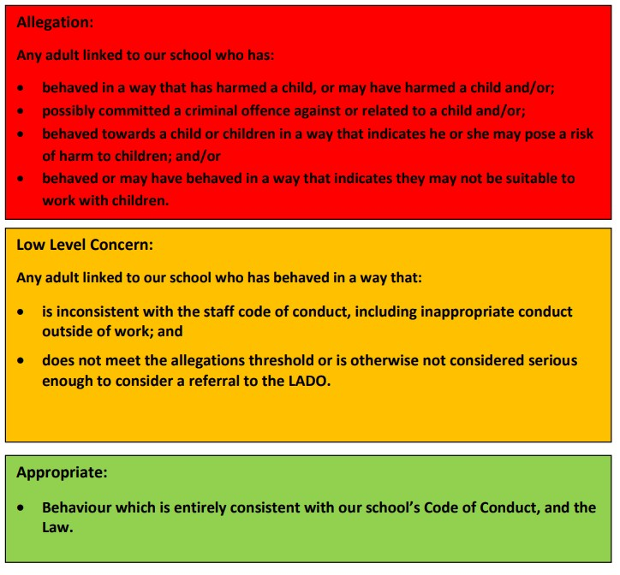

The term ‘low-level’ concern is any concern – no matter how small – that an adult working in or on behalf of the school may have acted in a way that:
- Is inconsistent with the staff code of conduct, including inappropriate conduct outside of work, and
- Does not meet the allegations threshold or is otherwise not considered serious enough to consider a referral to the designated officer at the local authority

Examples of such behaviour could include, but are not limited to:
- Being overly friendly with children
- Having favourites
- Taking photographs of children on their mobile phone
- Engaging with a child on a one-to-one basis in a secluded area or behind a closed door
- Humiliating pupils

Sharing low-level concerns
We recognise the importance of creating a culture of openness, trust and transparency to encourage all staff to confidentially share low-level concerns so that they can be addressed appropriately. We will create this culture by:
- Ensuring staff are clear about what appropriate behaviour is, and are confident in distinguishing expected and appropriate behaviour from concerning, problematic or inappropriate behaviour, in themselves and others
- Empowering staff to share any low-level concerns as per section 7.7 of this policy
- Empowering staff to self-refer
- Addressing unprofessional behaviour and supporting the individual to correct it at an early stage
- Providing a responsive, sensitive and proportionate handling of such concerns when they are raised
- Helping to identify any weakness in the school’s safeguarding system

Responding to low-level concerns
If the concern is raised via a third party, the headteacher will collect evidence where necessary by speaking:
- Directly to the person who raised the concern, unless it has been raised anonymously
- To the individual involved and any witnesses
The headteacher will use the information collected to categorise the type of behaviour and determine any further action, in line with the school’s staff code of conduct. The headteacher will be the ultimate decision-maker in respect of all low-level concerns, though they may wish to collaborate with the DSL.
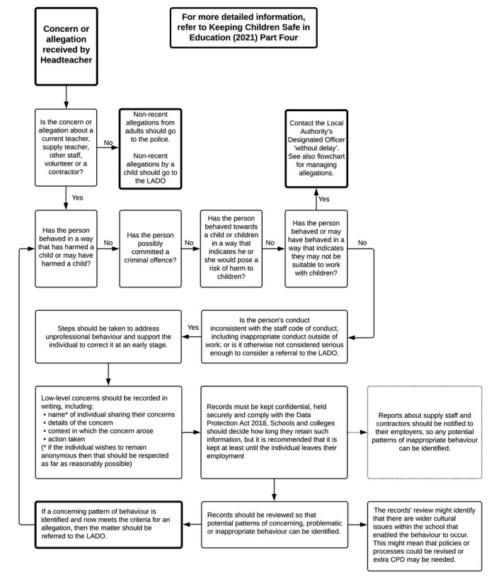

Record keeping
All low-level concerns will be recorded in writing on Staff Safe. In addition to details of the concern raised, records will include the context in which the concern arose, any action taken and the rationale for decisions and action taken.

Records will be:
- Kept confidential, held securely and comply with the DPA 2018 and UK GDPR
- Reviewed so that potential patterns of concerning, problematic or inappropriate behaviour can be identified. Where a pattern of such behaviour is identified, we will decide on a course of action, either through our disciplinary procedures or, where a pattern of behaviour moves from a concern to meeting the harm threshold as described in section 1 of this appendix, we will refer it to the designated officer at the local authority
- Retained at least until the individual leaves employment at the school
Where a low-level concern relates to a supply teacher or contractor, we will notify the individual’s employer, so any potential patterns of inappropriate behaviour can be identified.
Low Level Concerns Reporting Form

Please use this form to share any concern – no matter how small, and even if no more than a ‘nagging doubt’ – that an adult may have acted in a manner which:
- is not consistent with Highfield CE Primary School’s Code of Conduct, and/or
- relates to their conduct outside of work which, even if not linked to a particular act or omission, has caused a sense of unease about that adult’s suitability to work with children.

Where possible, please speak to the Headteacher as soon as possible. If the concern is about the Headteacher, please pass it onto the Chair of Governors or email them at a.hunt@highfieldschool.co.uk

Name (Optional):
Role:
Date and time completing this form:
Details of individual for whom the concern is about
Name:
Role:
Details of Concerns
Please provide a concise record – including brief context in which the low-level concern arose, and details which are chronological, and as precise and accurate as possible – of any such concern and relevant incident(s) (and please use a separate sheet if necessary). The record should be signed, timed and dated.

Signature:
For use by Headteacher upon receipt of the concern
Date and time concern received:
Signature Role:
Actions to be taken and follow-up:
References
We will not include low-level concerns in references unless:
- The concern (or group of concerns) has met the threshold for referral to the designated officer at the local authority and is found to be substantiated; and/or
- The concern (or group of concerns) relates to issues which would ordinarily be included in a reference, such as misconduct or poor performance

Southampton Safeguarding Contacts & Numbers
The LA’s Strategic Lead Officer for Safeguarding in Education:
Director for Children and Families: Robert Henderson
Safeguarding Lead for Education Settings within Southampton Local Authority school improvement:
Alison Philpott: Alison.philpott@southampton.gov.uk
Southampton Local Authority Designated Officer (LADO):
Jemma Swann Tel: 023 8091 5535 / 07500 952 037
Email: lado@southampton.gov.uk
Children’s Resource Service (Southampton’s Multi Safeguarding Hub)
Tel: 023 80 832300 (Professionals Number) or 023 80833336
Out of hours team: 023 8023 3344
Online referral https://scccrmportal.southampton.gov.uk/services/request-childrens-resourceservice
Child Performance and Child Employment LA Lead:

Grace Morris and Julie Stubbington: Child.Employment@Southampton.gov.uk

Southampton Local Safeguarding Board:

Independent Chair: Keith Makin

Manager: Sarah Lawrence

Tel: 023 8083 2995

Prevent Officer for Hampshire and Southampton:

Wendy Steward: Wendy.steward@hampshire.pnn.police.uk

Tel: 07796191771

Child Missing Education leader:

Eliza Johnson (Civic Centre): Sophie.bains@southampton.gov.uk

Tel: 023 80833666

SCC MET hub lead:

Laura Tanner:

laura.tanner@southampton.gov.uk

Lead for Vulnerable Pupil Officer:

Tina Selby: Tina.selby@southampton.gov.uk

Tel: 02380 833889

Virtual Headteacher for Children Looked After:

Maria Anderson: Maria.anderson@southampton.gov.uk

Tel: 02380 833480

Queries regarding advice for children who have had/ever had a social worker

helen.brown@southampton.gov.uk

Children and Families First Team
(
Early Help
):

Mia Wren

Mia.wren@southampton.gov.uk

Tel: 02380 833951

Educational Welfare Officer for
SCHOOL

xxxxxxxxxxxx

