Highfield CE Primary School
Behaviour Policy



Approved by: The Governing Body |  | Date: May 2025
Last reviewed on: May 2025
Next review due by: May 2027

Love the Lord your God with all your heart and with all your soul and with all your mind ... love your neighbour as yourself.

(Matt 22:37-39)

Our Vision and Values
At Highfield CE Primary School, our Christian values of Courage, Respect and Peace underpin all that we do. We aim to foster a safe, inclusive and inspiring environment where every child is nurtured academically, socially, emotionally and spiritually.

This policy outlines our approach to behaviour management, helping pupils learn how to make positive choices, form strong relationships and grow into responsible citizens.

Aims of the Policy
- Promote a shared understanding of high expectations for behaviour and relationships.
- Create a calm, happy school where children feel safe and respected.
- Help children learn to make good choices and take responsibility.
- Use positive reinforcement and restorative practices to build trust and accountability.
- Ensure staff, pupils and families work in partnership to support behaviour.
- Comply with DfE statutory guidance (Behaviour in Schools 2024, Searching and Screening 2022, Exclusion 2024).

Behaviour Expectations: Our Golden Rules
Children are explicitly taught and reminded to be:
- Ready – prepared for learning, listening, focused and taking part.
- Respectful – towards adults, peers, the environment and themselves.
- Safe – making choices that keep themselves and others safe.

These are reinforced in every classroom, around school, and in collective worship.

Promoting Positive Behaviour
We believe children respond best to encouragement and praise. All staff:
- Model respectful and caring behaviour.
- Build strong, trusting relationships with pupils.
- Teach and remind children of expected behaviours.
- Use consistent language and routines to support success.

Roles and Responsibilities
At Highfield Church of England Primary School, we believe that for children to thrive and make exceptional progress, everyone in our school community has a shared responsibility to act with kindness, respect, and integrity. A merged community joint rules and poster can be seen in Appendix A.
Pupils will:
- Follow the school's Golden Rules: Ready, Respectful, Safe.
- Take responsibility for their actions and words.
- Listen to adults and follow instructions the first time.
- Show kindness and care to others.
- Report any concerns or unsafe behaviour to a trusted adult.

All staff will:
- Model respectful and safe behaviour at all times.
- Set clear expectations and routines in their classrooms and around school.
- Recognise and reward positive behaviour regularly.
- Apply consequences consistently and fairly when needed.
- Use restorative conversations to help children reflect and rebuild relationships.
- Record behaviour incidents as required and involve parents where necessary.

Senior Leaders will:
- Lead by example and uphold high expectations across the school.
- Support staff in managing behaviour, especially at Level 2 and Level 3.
- Monitor behaviour records and analyse patterns or concerns.
- Ensure staff are trained in behaviour strategies and safeguarding.
- Oversee exclusions and reintegration processes.
- Communicate behaviour expectations clearly to all stakeholders.

Parents and Carers will:
- Support the school’s values and behaviour policy.
- Reinforce positive behaviour and respectful attitudes at home.
- Work in partnership with school when concerns arise.
- Communicate openly with staff and raise concerns early.
- Attend reintegration or behaviour support meetings as needed.

Governing Body will:
- Monitor the effectiveness of the behaviour policy through reports and data.
- Ensure the policy complies with current legislation.
- Support the Headteacher in upholding high behaviour standards.
- Review any exclusions as required by law.

Rewards and Recognition
At Highfield Church of England Primary School, we believe that good behaviour is best promoted and developed by recognising and celebrating positive actions and the valuable contributions children make to school life. We encourage all members of our community to show courage, respect, and peace in everything they do. Rewards and Recognition include:
- Verbal praise, stickers, team points, Dojo’s at the Juniors, certificates and Golden Leaves
- Showing work to another adult or the Headteacher.
- Celebration Worship.
- Emails or phone calls home.
- Termly value awards and Headteacher’s Award.
- We reward children by giving them specific responsibilities to role model excellent behaviour.

Restorative Approach
When behaviour falls below expectations, we use a restorative approach to:
- Support reflection and learning from mistakes.
- Rebuild relationships and repair harm.
- Empower pupils to take ownership and make amends.

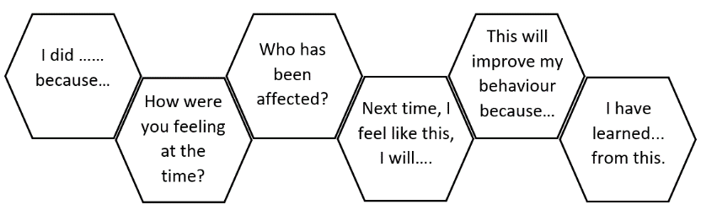
Staff may use questions like:
- What happened?
- How were you feeling at the time?
- Who has been affected?
- What needs to happen to put things right?
- What would you do differently next time?

Consequences
Where necessary, consequences are applied in line with the behaviour level (please see below). These may include:
- Time out in another class
- Loss of playtime or privileges
- Reflection activity (e.g. letter of apology, behaviour review sheet)
- Temporary removal from class (internal exclusion)
- Report cards or home-school logs
- Fixed-term suspension (in line with DfE guidance)

Children are always supported to reintegrate following consequences.

Behaviour Levels and Responses
Level | Behaviours | Response / Action
1 | - Calling out, interrupting a teacher during input, chatting when being asked to work in silence  - Not following instructions for the first time  - Distracting others  - Not staying on task  - Running indoors  - Minor damage to property (e.g. defacing work book)  - Excluding others, mild teasing, whispering about others, not sharing | - First instance:  - verbal reminder or warning  - opportunity to reset behaviour  - possible change of seat or separation from peers  - Second instance (Juniors)  - Name written on the board  - Class Teacher or Teaching Assistant logs a Level 1 Behaviour incident on ClassDojo
2 | - Repeated demonstration of Level 1 behaviours  - Answering back or arguing with staff  - Disrespectful tone or body language e.g. speaking with sarcasm, tutting, sighing folding arms and turning away when being spoken to.  - Name calling, making fun of someone’s appearance, spreading rumours or gossip, mocking someone, writing unkind notes  - Deliberate avoidance of work  - Inappropriate physical contact (hitting, kicking, poking, pushing, biting), not coming from aggression or intent to hurt  - Inciting others to misbehave  - Deliberately attempting to access inappropriate websites or search for inappropriate terms | - Infants: Name moved to cloud.  - Reflection Sheet (Appendix B) completed which is sent home and scanned and uploaded to CPOMS and labelled Level 2.  - Parents contacted via email or phone call by class teacher  - Juniors: Tick placed next to the child's name on the board and logged by teacher / TA as Level 2 on ClassDojo  - Child sent to the Phase Leader’s classroom (with work to complete, if appropriate). The child/children may work outside the Phase Leaders classroom dependent on space.  - Phase Leader leads a reflective discussion and supports the child to complete a Reflection Sheet (Appendix B). The child/children may work outside the Phase Leaders classroom dependent on space.  - The Reflection Sheet is sent home and scanned and uploaded to CPOMS  - Parents contacted via email or phone call by class teacher  - Loss of Golden Time privilege
3 | - Repeated demonstration of Level 2 behaviours  - Deliberate damaging of property e.g. breaking furniture on purpose, damaging displays or other pupils’ work beyond repair, writing on furniture.  - Swearing at adults or other children  - Deliberate physical aggression or threatening behaviour to deliberately cause harm or pain (hitting, kicking, poking, pushing, biting, fighting) with intent to hurt physically or emotionally  - Bullying (in-person/online) including targeted words or actions which make a person feel frightened, humiliated or ridiculed on a regular basis.  - Racial, homophobic, sexual or discriminatory language  - Bring in or using banned/dangerous items | - Infants: Name moved to cloud  - Child sent to a member of the Senior Leadership Team or the Headteacher  - Completion of a Reflection Sheet (Appendix B), sent home and uploaded to CPOMS labelled Level 3.  - Parents contacted via a phone call (not email) by a member of SLT  - Internal exclusion (e.g. breaktime, lunchtime, or afternoon session, dependent on severity/frequency) or suspension, decision made by Headteacher  - Juniors: Second tick placed next to the child's name on the board and logged by teacher / TA as Level 3 on ClassDojo  - Child sent to a member of the Senior Leadership Team or the Headteacher  - Completion of a Reflection Sheet (Appendix B), sent home and uploaded to CPOMS  - Parents contacted via a phone call (not email) by a member of SLT  - Internal exclusion (e.g. breaktime, lunchtime, or afternoon session, dependent on severity/frequency) or suspension, decision made by Headteacher  - Loss of Golden Time privilege
A member of SLT is able to use their own judgement to decide on the level of a behaviour if it doesn’t correspond with any bullet points mentioned in the table above.

Support and Early Intervention
We recognise that some children need additional support with behaviour. Staff:
- Work closely with SENDCo where behaviour may be linked to additional needs.
- Provide reasonable adjustments for pupils with SEND.
- Use pastoral support plans, risk assessments, and personalised behaviour strategies.
- Involve parents/carers early when concerns emerge.

Interventions may include:
- Small group social skills work
- Emotional Literacy Support (ELSA)
- Individualised behaviour targets and rewards

Internal Exclusion / Calm Space
Where needed, pupils may be supported in a calm space for a fixed time away from class. The purpose is to reflect, regulate emotions and prepare for reintegration. This is always supervised, recorded and communicated with parents.

Re-integration
Following a serious incident or suspension, a reintegration meeting is held with the child, parent/carer, and a member of SLT. This reviews what happened, restores expectations and outlines support going forward (see Exclusion Policy).

Bullying and Discriminatory Behaviour
We have zero tolerance for bullying, including racism, sexism, homophobia, or any behaviour targeting protected characteristics.

All incidents are investigated and addressed. Support is offered to both the victim and perpetrator. Sanctions are proportionate and escalate where behaviour does not improve (see our Anti-Bullying Policy).

Pupil Voice and Inclusion
Pupils are involved in shaping behaviour expectations through school council and class discussions. We ensure all children, regardless of background or need, feel heard, respected and safe.

Staff Training and Development
All staff receive regular training on behaviour expectations, positive reinforcement and restorative practice. Staff are supported to use consistent strategies and language to reinforce expectations and manage behaviour calmly. CPD is regularly updated to reflect school needs, national guidance and safeguarding considerations.

Behaviour Monitoring and Evaluation
Behaviour logs are maintained and reviewed regularly by senior leaders to:
- Track individual and whole-school behaviour patterns
- Identify children who need additional support
- Evaluate the effectiveness of interventions and the behaviour policy

Findings are reported to governors and used to inform staff training and policy updates.

Partnership with Parents
We work closely with parents to:
- Promote shared expectations
- Communicate successes and concerns promptly
- Support families where behaviour is linked to emotional or environmental factors

We expect all parents to:
- Support the school’s behaviour policy
- Reinforce key messages at home
- Communicate any concerns early

Behaviour Outside of School
Pupils represent Highfield even when off-site. Behaviour expectations apply when:
- On trips, visits or residentials
- Walking to/from school
- Wearing uniform or identifiable as a pupil of the school

Poor behaviour in public that affects the safety of others or the reputation of the school may lead to consequences.

Searching, Screening and Confiscation
In line with DfE guidance, the Headteacher or authorised staff may search a pupil or their belongings where there is reason to suspect possession of prohibited items, such as:
- Weapons, alcohol, drugs
- Stolen items
- Fireworks or pornography
- Items intended to cause harm or disruption

Confiscated items are stored safely and parents informed where appropriate.

Use of Reasonable Force
Staff may use reasonable force when necessary to:
- Prevent injury or damage
- Remove a child from danger

This is always a last resort, recorded and communicated with parents. Staff are trained in de-escalation techniques and safe handling.

Malicious Allegations Against Staff
Any false or malicious allegation made against a staff member will be treated seriously. Following investigation, sanctions may apply up to and including exclusion.

Monitoring and Evaluation
Behaviour logs are reviewed regularly by SLT to:
- Monitor patterns
- Identify children needing support
- Review effectiveness of policy implementation

This policy is reviewed annually with input from staff, governors, parents and pupils.

Together, we strive to live out our values of Courage, Respect and Peace in all we do.

Appendix A: Community Behaviour Poster
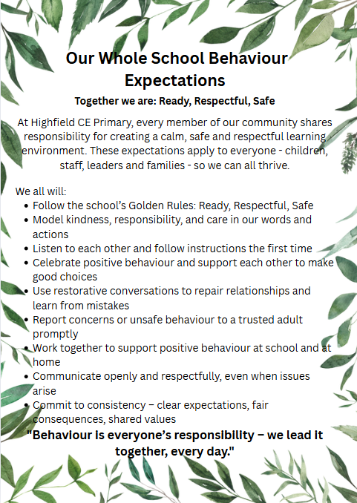

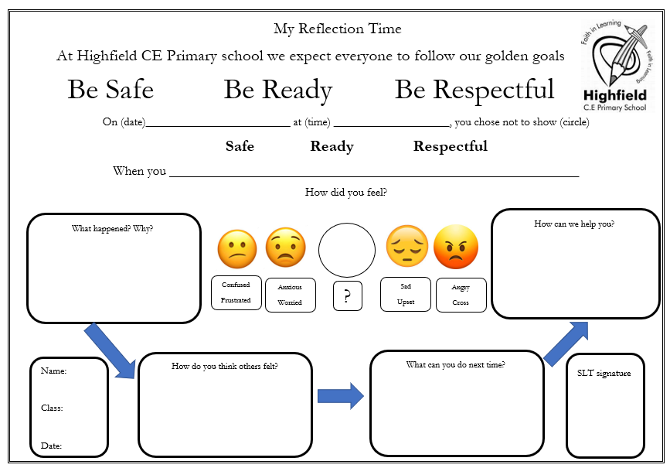

Appendix B: My Reflection Time Sheet

