
Highfield C of E Primary School

Reading Time Book Spine – Cycle 1
Class: North America
Autumn 1 | Autumn 2 | Spring 1 | Spring 2 | Summer 1 | Summer 2
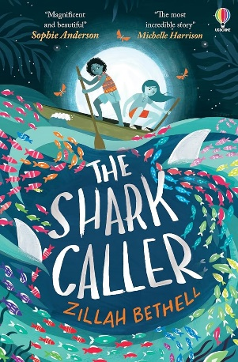  The Shark Caller  by Zillah Bethel |  |   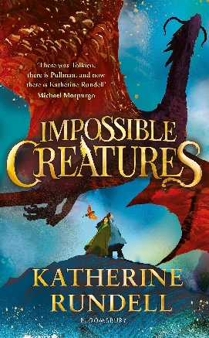  Impossible Creatures  by Katherine Rundell |  | 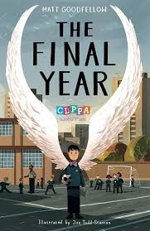  The Final Year by  Matt Goodfellow

