
Highfield C of E Primary School

Reading Time Book Spine – Cycle 1
Class: Europe
Autumn 1 | Autumn 2 | Spring 1 | Spring 2 | Summer 1 | Summer 2
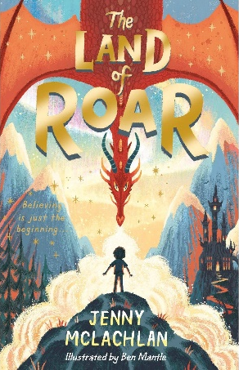 |  | 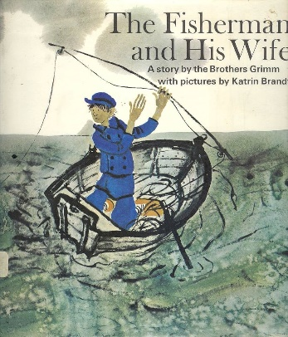 | 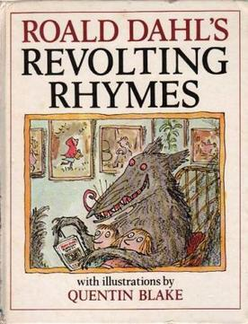 | 

