Autumn 1 | Autumn 2 | Spring 1 | Spring 2 | Summer 1 | Summer 2
The Great Kapok Tree  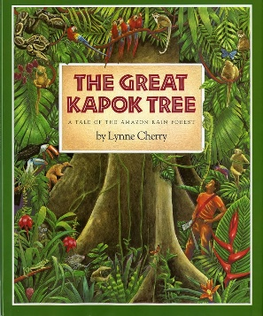 | The Letter with the Gold Stamp  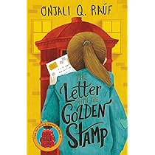 | Why the Whales came by Michael Morpurgo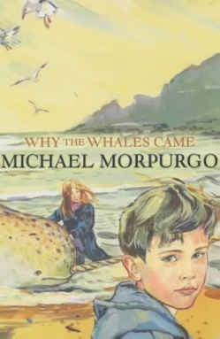  A Day in the Life of a Poo, a Gnu and You by Mike Barfield  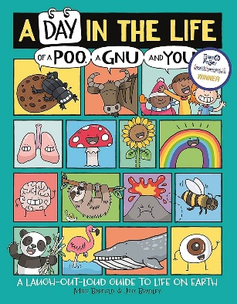 | 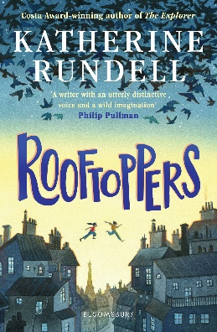  Rooftoppers by Katherine Rundell | 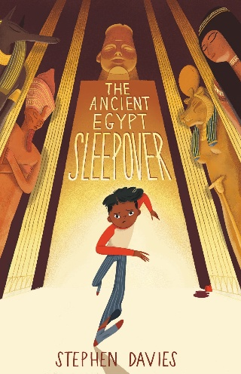  The Ancient Egypt Sleepover by Stephen Davies | 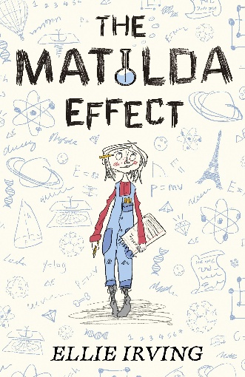  The Matilda Effect by Ellie Irving

